**z**

**August 24th & 25th, 2024**

St. Lawrence County **57**th **Gem, Mineral & Jewelry Show**

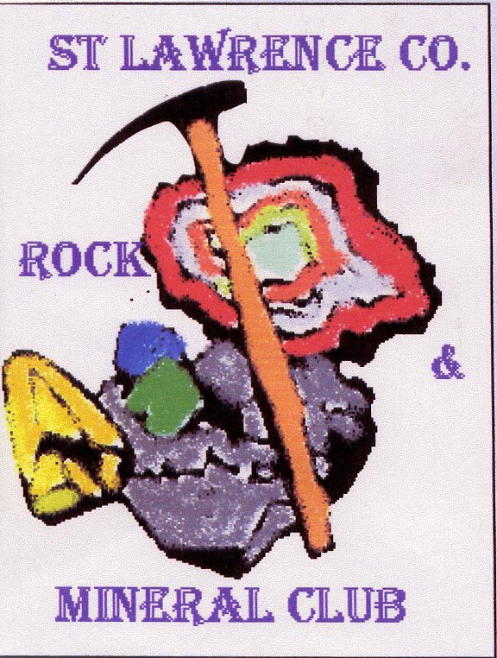

Come to the St. Lawrence Rock & Mineral Club’s Show at the **Canton, NY, Pavilion**, 90 Lincoln St. Add to your collection or browse beautiful mineral specimens, crystals and gems; fossils too!

**Awesome fluorescent minerals tent - a Must see!**

**Admission:** Adults $4.00; 12 & under free.

Fri. 8PM: Free kid’s fluorescent mineral hunt

Sat. Free mineral kits for kids; “Mineral ID”

Collecting field trip 9:00 AM

Sun. Gem tree classes

“Amethyst Cathedral” raffle 2PM

Silent Auctions: Saturday & Sunday

**Show Hours: Sat. 9:00 – 4:30; Sun. 9:00 - 3:00. Visit us @ stlawrencecountymineralclub.org**